oa

PARTNERS IN PROGRESS
Professional Development for
ABE Support Staff

November 7 - November 8, 2019

Minnesota Department of Education
Conference Center B
1500 Hwy. 36 W., Roseville, MN 55113

Sponsored by:

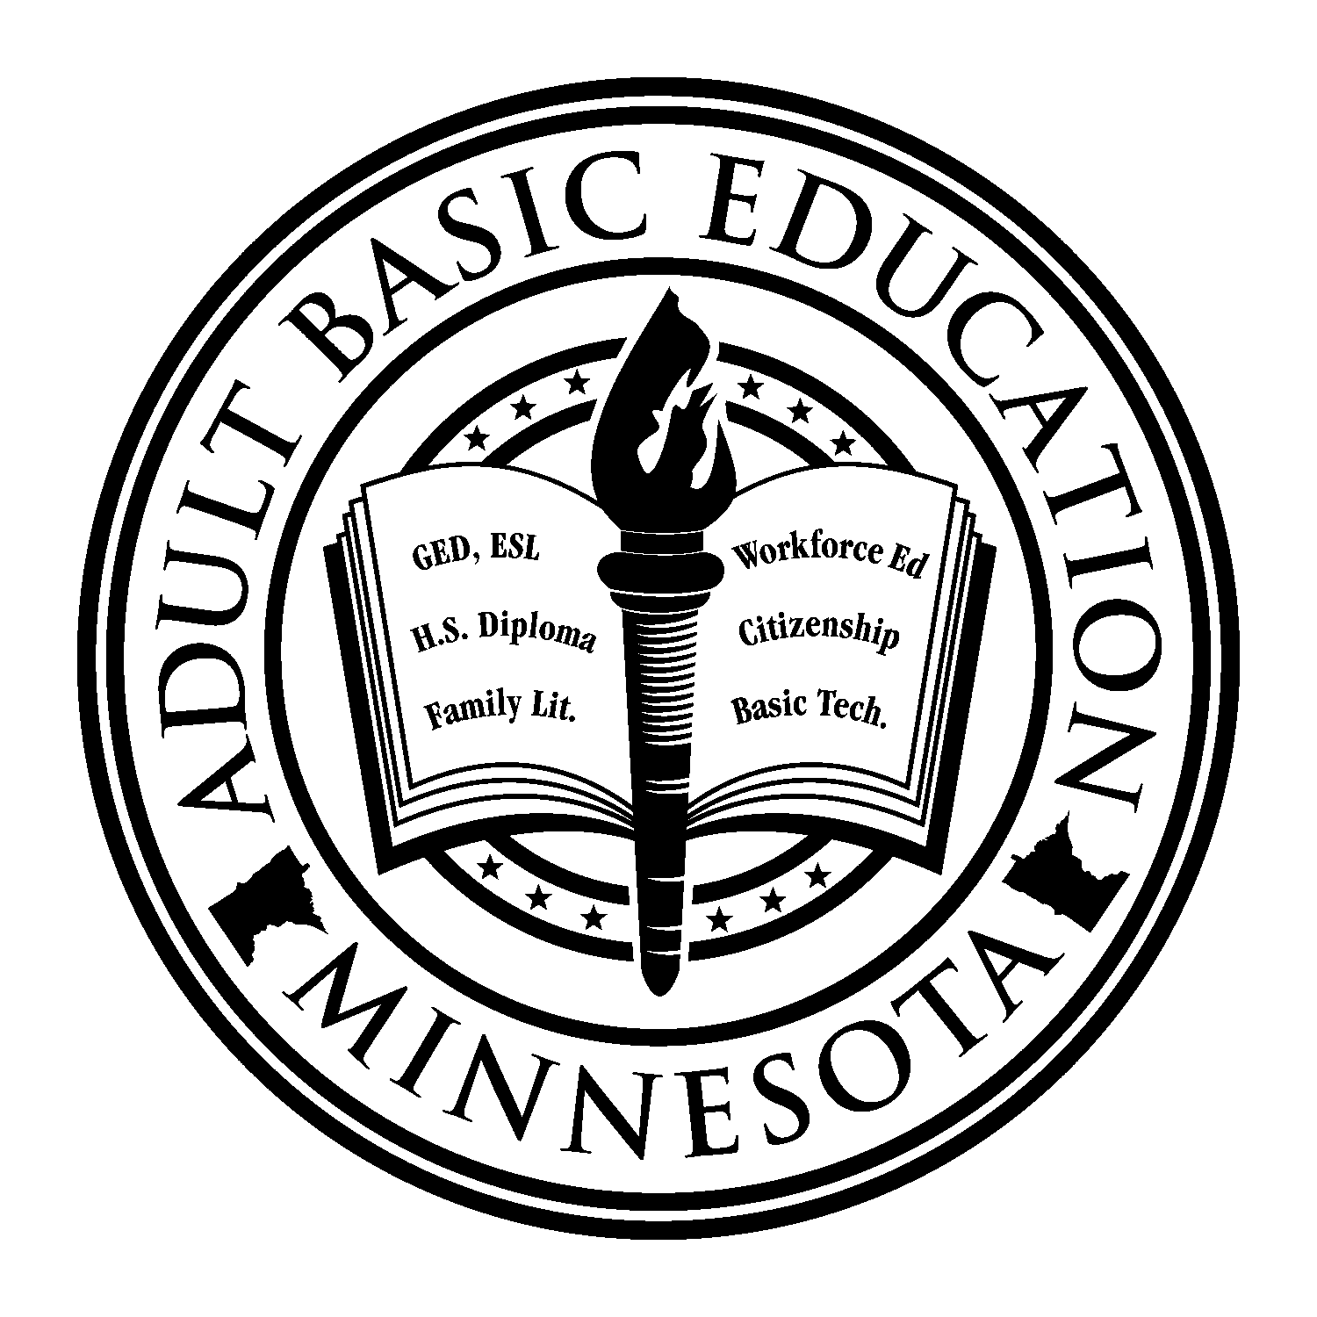
Minnesota Adult Basic Education Assessment Training –
Southwest Adult Basic Education

Minnesota Adult Basic Education –
Department of Education

Visit the ABE Support Services resource page on the mnabeassessment.com website: http://www.mnabeassessment.com/ click on the SPARC tab.

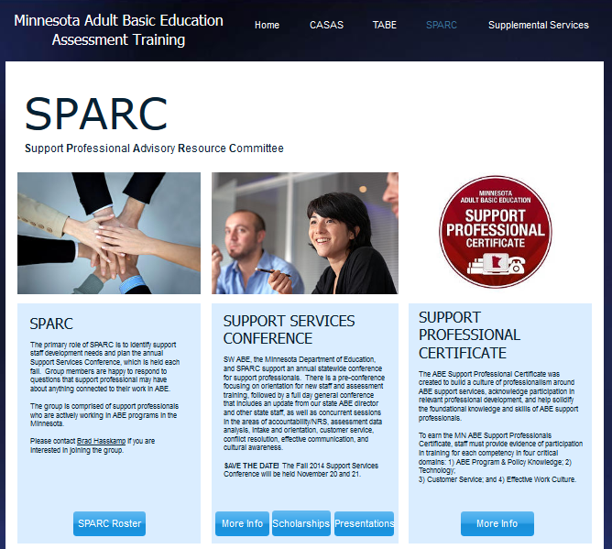
- The www.mnabeassessment.com website has resources and information on ABE in MN, accountability and NRS, assessment, teaching resources, Supplemental Services, and more
- The SPARC tab has information and contacts for the Support Professionals Advisory & Resource Committee (SPARC)
- There is also information regarding the annual Support Services Conference
- Learn more about the Support Professional Certificate

Visit the UPDATED MN ABE website http://www.mnabe.org/

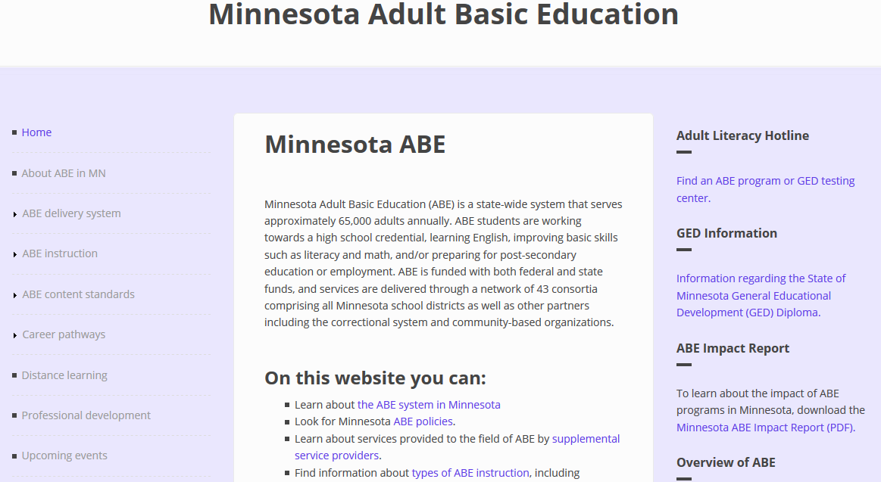

Resources and information on:
- ABE system in Minnesota
- ABE law and policy
- Accountability and NRS

- Contacts and directories
- Professional development
- Supplemental Service providers
See also the ABE Supplemental Services page on the SW ABE Assessment website:
https://www.mnabeassessment.com/supplemental-services

ABE Supplemental Service providers offer assistance to all approved ABE programs for activities such as professional development, volunteer training, low-incidence needs, and technological innovation.

Conference Agenda

Thursday, November 7 – MDE Conference Center B (CC-16, 17)

8:30 a.m.-9:00 a.m. |  | Registration/Refreshments
9:00 a.m.-12:00 p.m. |  | *ABE Support Staff Orientation – Becca Bair, Belinda Gonzalez, Tim Rowe, and Heather Williams
12:00-12:30 p.m. |  | Lunch (for those who pre-registered for lunch)
12:30-3:30 p.m. |  | *CASAS Implementation – Marty Olsen and Stacy Everding  This session covers selecting and using the appropriate CASAS test, interpreting test scores, and measuring student progress. Discussion will focus on CASAS appraisals, pre‐ and post‐tests, and introduce online instructional resources. Information about CASAS GOALS will be included. Participants who complete this session will be authorized to order and administer CASAS multiple-choice assessments.
3:30-3:45 p.m. |  | Break
3:45-5:45 p.m. |  | *TABE Implementation – Linda Keller and Dave Haugen  This session covers selecting and administering TABE 11&12, interpreting test scores, and measuring student progress. Discussion will focus on best practices for using the TABE Locator, and pre‐ and post‐tests. The latest updates on TABE 11&12 will be shared. Print and online instructional resources will be discussed.
* NOTE: These sessions are intended for anyone who is not CASAS or TABE certified, or is new to ABE. This means that you are welcome to attend this portion of the conference even if you do not have program support duties.

Friday, November 8– MDE Conference Center B (CC-15, 16, 17, 18)

8:30-9:00 a.m. |  | Registration/Refreshments
9:00-9:55 a.m. |  | Welcome/Opening Session
9:55-10:05 a.m. |  | Break
10:05-11:30 a.m. |  | Concurrent Session 1 (descriptions on following pages)
11:30 a.m.-12:10 p.m. |  | Lunch
12:10-1:35 p.m. |  | Concurrent Session 2 (descriptions on following pages)
1:35-1:45 p.m. |  | Break
1:45-3:10 p.m. |  | Concurrent Session 3 (descriptions on following pages)
3:10-3:25 p.m. |  | Closing Session & Evaluations

Session Schedule, Descriptions & Locations: November 8

TIME | SESSION | ROOM
8:30-9:00 | Registration and Refreshments
9:00-9:55 | Welcome – Jodi Versaw and Brad Hasskamp, MN Department of Education; Marty Olsen, SW ABE - Worthington and MN ABE Assessment Supplemental Services Grant; Heather Williams, Robbinsdale ABE, SPARC Chair | CC-15 & 16
9:55-10:05 | Break
CONCURRENT SESSION 1:
10:05-11:30 | CASAS and TABE Test Administration Recertification - Linda Keller and Marty Olsen  Is it time for your 5-year recertification as a test administrator? Come to this session to hear the latest on TABE 11&12 and CASAS GOALS. We will review standardized testing and address questions you may have about administering these tests. This session is for experienced test administrators. | CC-15
 | How Mental Illness Impacts Student Learning & What You Can Do About It - Wendy Sweeney  Learn about student trauma and common mental health disorders. Discuss and uncover cultural views on mental health and disabilities. Discover strategies about how to manage behavior and improve learning. Gain knowledge about how to approach & help students with mental health challenges. This course meets CEU requirements for understanding student mental illness and trauma. | CC-16
 | SiD Basics - Jenny Schlukebier  An introduction to SiD - we will focus on understanding why we track certain information, navigating SiD screens, finding information, inputting new student data, recording attendance, running basic reports, and how to find or ask for SiD Help. | CC-17
 | Racial Equity 101 - Wendy Roberts and Madeleine Emanuel  Join us for a presentation and conversation on racial equity. During this session, presenters and participants will discuss important terms, including racism, white supremacy, white privilege and white fragility. We’ll also practice responding to instances of racism using various scenarios. Participants will leave with resources to address and dismantle racism. This is a great session for those who are newer to conversations on race or those who would like to share their knowledge and experiences with others. All are welcome! | CC-18
11:30 - 12:10 | Lunch and networking | CC-15/16

TIME | SESSION | ROOM
CONCURRENT SESSION 2:
12:10-1:35 | New Tests, New Practices - ABE Program Panel Discussion  Join us for a panel discussion about initial implementation of CASAS GOALS and TABE 11/12. Program representatives will share which assessments they’re using, what challenges and successes they’ve had, testing resources they’ve developed or found, and more. Hear from ABE staff in the state about how they are adapting with the new tests, and share your own experiences. | CC-15
 | Tech Tools for Working in Teams - Jason Brazier  New technology allows staff to easily facilitate communication among members of a team and reduce the time and expense associated with group work. This session will introduce participants to a number of options that allow for staff group sharing, remote working and real-time conversations. | CC-16
 | Support Professional Certificate - Jennifer Hennes  The ABE Support Professional’s Certificate is back online! Come to this session to learn about the Support Professional’s Certificate and requirements to obtain yours. There will be time for questions and time to work on filling out your information. Paper copies will be available or bring your laptop. | CC-17
 | Reppin’ the Rainbow: LGBTQIA+Representation in ABE - Erin Cary, Kris Klas, Jamie Kreil  In this session, ABE professionals in the LGBTQIA+ community will invite participants to reflect on and discuss topics of gender and sexuality in ABE classrooms and professional settings. Materials, resources, and research will be shared, as well. It is our intention to create a space where participants are welcome, but not required to share aspects of their identify or experiences related to the topic. | CC-18
1:35-1:45 | Break

TIME | SESSION | ROOM
CONCURRENT SESSION 3:
1:45-3:10 | ABE Accountability 101 - Brad Hasskamp and Heather Williams  Under the Workforce Innovation and Opportunity Act, accountability for Adult Basic Education (ABE) programs has changed. Learn the details of how we are measuring success with the federal government, what is Measurable Skill Gain, when are we expected to have data and reports in the database, how are we implementing new tests, and what the other new rules of the ABE game are! This is essential for local ABE programs to know. | CC-15
 | SiD Advanced Topics - Jenny Schlukebier  This session is for seasoned SiD users. We’ll talk about new (and under-utilized) features and reports including hotline, student logs, student re-entry and GED data match. There will be time for questions. | CC-16
 | GED® for new ABE Educators, Administrators - Mellissa Hultstrand, Business Process Analyst & Trainer, GED Testing Service  Many people are new to teaching GED® classes, and turnover in local GED® Administrators have many people learning what the GED® test is all about both from an instructional point-of-view and how to administer the tests. Come and learn about new educator tools available on the new website. Also, learn the basics of test administration. | CC-17
 | Navigating the Immigration Landscape - Alison Olson Cox, Managing Attorney, Mid-Minnesota Legal Aid  This presentation will discuss the current immigration landscape. We will dive in to the myriad of issues facing non-citizens in our community and will separate fact from rumor and discuss the chilling effect the current rhetoric has had on non-citizens accessing the legal system. | CC-18
3:10-3:25 | Closing Session & Evaluations (in concurrent session rooms)

Many Thanks
to those who planned and/or supported this conference!

- Becca Bair, Great Rivers Adult Education Consortium
- Karen Blees, SPCLC
- Stacy Dietrich Varney, International Institute of MN
- Shannon Drew, Metro South
- Marylynn Dvorak, Metro South ABE
- Lee Fang, Minneapolis ABE
- Belinda Gonzalez, Minneapolis ABE
- Jennifer Hennes, Southwest Metro ABE
- Wendy Her, Adult Options in Education
- Linda Jacobs-Buse, South Suburban ABE
- Linda Keller, Metro North ABE
- Astrid Liden, MN Department of Education
- Marty Olsen, Southwest ABE
- Tim Rowe, Minneapolis ABE
- Jenny Schlukebier, Urban Planet
- Heather Williams, Robbinsdale Adult Academic Program
- Cherie Eichinger, MN Department of Education
- Brad Hasskamp, MN Department of Education
- Jodi Versaw, MN Department of Education
- Todd Wagner, MN Department of Education

Introducing Our Presenters
Jason Brazier is the Technology Administrator for the Minnesota Literacy Council. He has provided training and technology support in the ABE field at the local, state, and national levels. jbrazier@mnliteracy.org
Erin Cary (she/her/hers) has been an ABE teacher and manager for ten years. Her MA ESL capstone addresses learner identity and self-advocacy. She is queer. erin@lyndale.org

Madeleine Emanuel is the Minnesota Literacy Council’s Donor Relations and Database Specialist. She previously worked as the Institutional Giving Associate at A Noise Within where she founded the organization’s Equity Committee. memanuel@mnliteracy.org

Stacy Everding teaches Citizenship and English as a Second Language for Worthington ABE. She also serves as Distance Learning Coordinator for SW ABE, and is the Adult Diploma advisor for SW ABE South. She is currently completing her training to be a fully certified CASAS trainer for Minnesota. stacy.everding@isd518.net
Brad Hasskamp is the Adult Secondary Credential and Education Policy Specialist at the Minnesota Department of Education. With his work on the state ABE team, his primary responsibilities include state high school equivalency test administration, standard adult high school diploma administration, and federal and state policy implementation. brad.hasskamp@state.mn.us
Dave Haugen currently works for Pearson VUE in the area of testing accommodations, and has worked in ABE for both Minneapolis ABE, and Metro North ABE. He also teaches CDL and Citizenship part-time for Metro North ABE. dave.w.haugen@gmail.com
Jennifer Hennes is the ABE Program Specialist for SouthWest Metro Intermediate District in Shakopee. jhennes@swmetro.k12.mn.us
Mellissa Hultstrand works with GED State Administrators, Test Administrators, Adult Educators, and GED Customer Support Center staff across the US and Internationally. She frequently delivers training sessions on GED products and services. Mellissa.Hultstrand@ged.com
Linda Keller is the ABE Accountability Coordinator for Metro North ABE and manages SiD for the consortia, as well as provides CASAS and TABE Implementation Training locally, and through the Supplemental Services Grant with MN ABE Assessment since 2008. lindam.keller@ahschools.us
Kris Klas (they/their/theirs) received their MA ESL and ABE teaching license from the U of MN. They have been an ABE Instructor since 2010 and recently transitioned to St. Paul Public Schools. kristen.klas@gmail.com

Jamie Kreil, Ph.D. (she/her/hers) is an ELL instructor at CRAEC and Adjunct Faculty at Hamline University. Active in ABE since 2007, her work has focused on ABE credentialing and professional issues. jamie.l.kreil@gmail.com

Marty Olsen is the ABE coordinator for SW ABE South. She is a nationally-certified CASAS assessment trainer, a state-certified TABE assessment trainer, and manages the assessment training supplemental services grant for SW ABE. martha.olsen@gmail.com
Alison M. Olson Cox is the Managing Attorney for the Immigration Law Project at Mid-Minnesota Legal Aid. She has been with MMLA for over eleven years, and has handled a wide variety of immigration matters including complex naturalization cases, court representation, and immigration benefits for survivors of domestic violence. alisoncox@mylegalaid.org.
Wendy Roberts is the Volunteer Outreach and Hotline Manager at the Minnesota Literacy Council. She is also the LAN Volunteer Engagement Committee Co-Chair and serves on the literacy council’s Diversity, Equity and Inclusion Governance Committee. wroberts@mnliteracy.org
Jenny Schlukebier works at Urban Planet in development and support of the SiD data system. Jenny comes from a background of working on accountability in ABE at St. Paul Public Schools ABE (Hubbs Center) and MLC. jenny@urbanplanet.com
Wendy Sweeney is the PANDA Manager and a Licensed Psychologist with Minnesota ABE Disability Specialists, a support network provider for MDE. Wendy is also a Licensed Psychologist and works at a mental health clinic. Wendy specializes in learning disabilities, ADHD and mental health disorders. She has provided disability services for ABE since 2007. wendy_sweeney@rdale.org
Jodi Versaw is the Adult Basic Education Program Quality Specialist at the Minnesota Department of Education. With her work on the state ABE team, her primary responsibilities include the five-year narrative, program improvement, and program support. jodi.versaw@state.mn.us
Todd Wagner is the State Adult Basic Education Director at the Minnesota Department of Education. Along with leading the state ABE team, his primary responsibilities include data, budgets, and program accountability. todd.wagner@state.mn.us
Heather Williams works several roles within ABE: in Robbinsdale she is the Student Data and Assessment Specialist; she is a GED test proctor; she is also part of the statewide Professional Development committee. heather_williams@rdale.org

